Messages from the Director
Jimma University Career Development and Business innovation Center (CDBIC) is established in Sep. 2015 to create a new and better future in career skills development and entrepreneur mindset towards fast-track Jimma University graduating employment. In this regards, JU-CDBIC for the last three years aggressively working on re-establishing the center, Capacity building and create awareness to the JU community and surrounding partners and potential employers. By doing this, collaborating with partner Career service center was fully furnished with facilities, more than 60 staffs were certified Training of Trainer (ToT) of Life and soft skill training facilitation, Career Readiness and Job searching skills and these activities create continues communication with college’s deans and directors. Now the above-mentioned activities attract potential employers to create employments opportunities to our graduating with in a year.
One of the many reasons for unemployment of university graduates is lack of skills to launch a new business. So, one of the principal objectives of JU-CDEC is to facilitate Entrepreneur Mindset merge with Career Readiness Training. In this regard even the center was not the only practitioner, tries to create entrepreneur mind set around the staff and graduating students. So as Jimma University Career Development and Business innovation Center Director, we are in the track and should be excel to outreach every graduating student through continues skill discovering and developing schemes are designed.
Thank you
Ahmed Mohammed
Jimma University Career Development and Business innovation Center Director

The role of career services is invaluable to make students capable of selecting the most fitting career path with their ability, interest and personality.
- Ensure that effective capacity building training is provided in collaboration with relevant stakeholders to ensure that graduates receive skills and attitude training based on initial research.
- Professional development skills, work motivation; Discipline, ethics, life skills, and related capacity building training will be evaluated to ensure that coaches and staff are problem solvers.
- Provides the necessary resources for the development of the University community (leadership, administrative staff and faculty) for the development of professional attitude awareness training; Proves its practicality.
- Ensure that professional development forums for students, industry leaders and industry owners are organized at the college or institution level.
- Strengthen job skills, youth capacity building, human resource development, industry development, entrepreneurship development, in collaboration with national and international development partners working in research and related activities. Encourage entrepreneurship, innovation based on the needs of graduates, center staff and the university community.
- Coordinates students' access to personal, educational level, skills and experience information preparation, employment application, job interview, communication skills, reasoning skills, time management and related capacity building training before graduation.
- Prepare and coordinate annual job fair will be set up for job seekers and employers' job seekers to introduce them to the industry and express their qualifications, It proves to be practical.

From the main events Organized and conducted by the center:
1.Instructor ToT Employability and Job Searching skill Training, 51 Instructor from all colleges were participated and successfully completed.
Jimma University Career Development and Business Innovation center has been conducted Training of Trainer's " Instructor Employability Skill Training" with collaboration with key partner of the sectors Dereja.com. In this Training 30 Instructors were participated starting from July 2021 and February 2022 completed successfully.

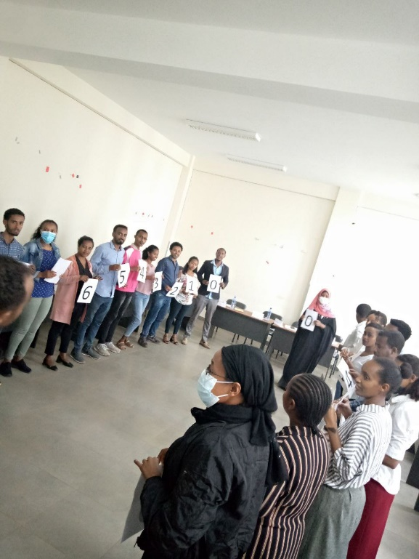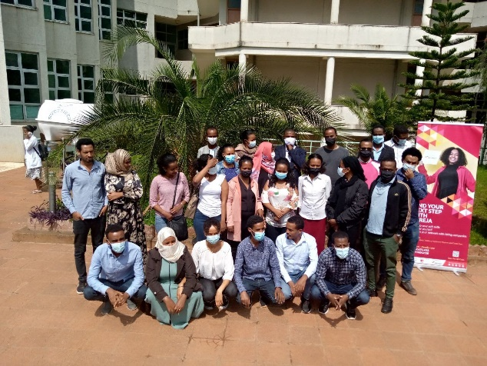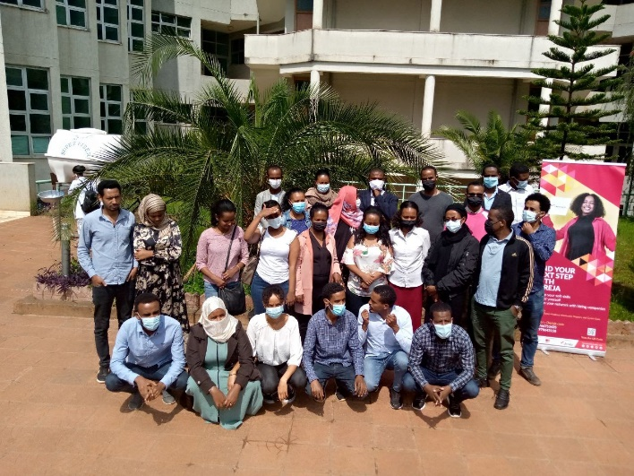
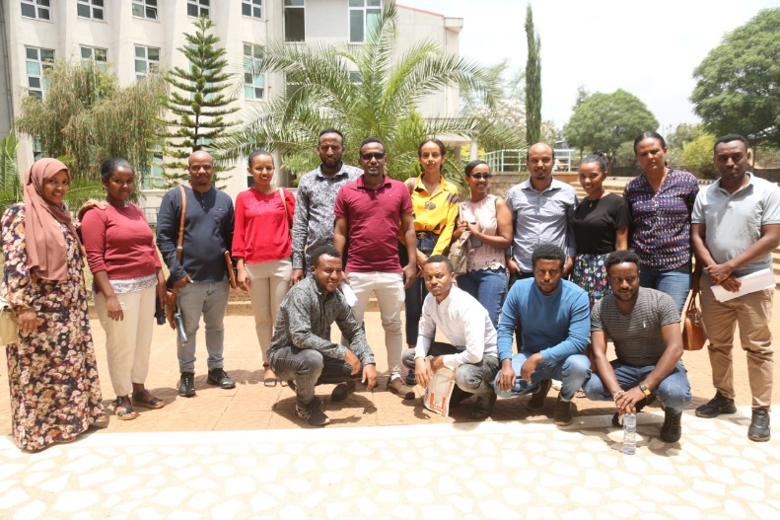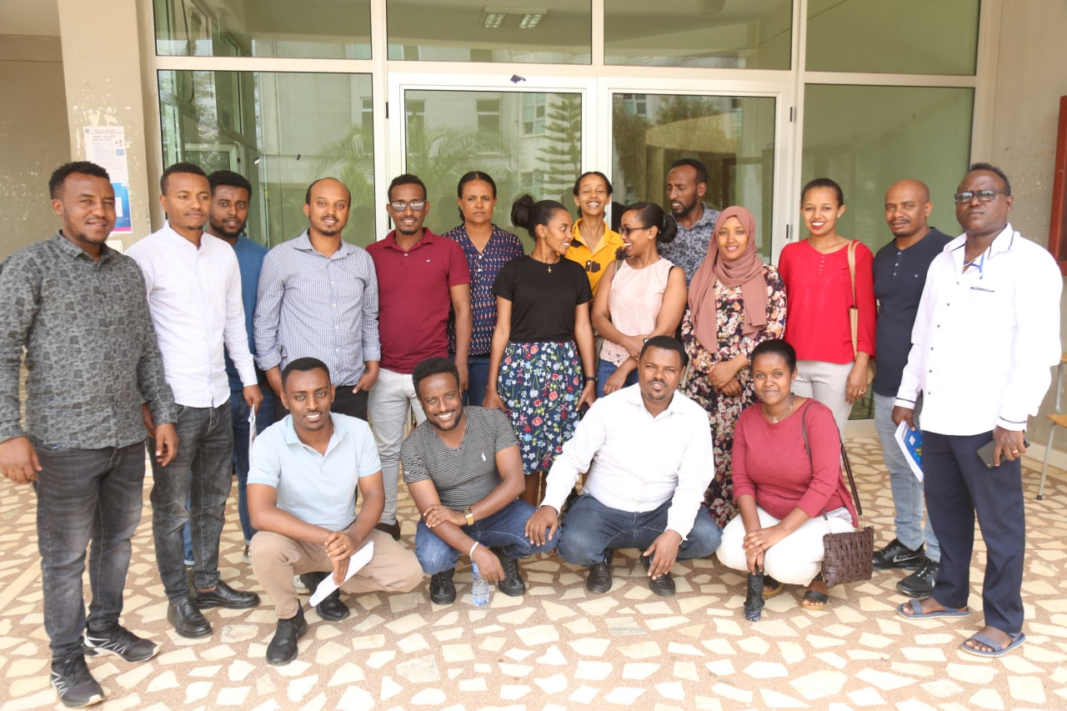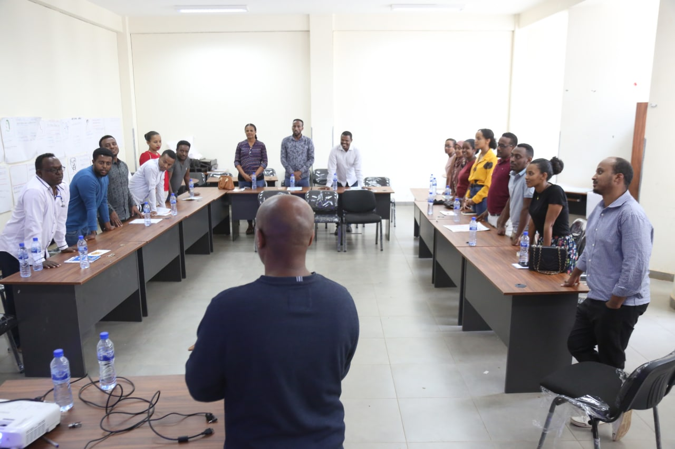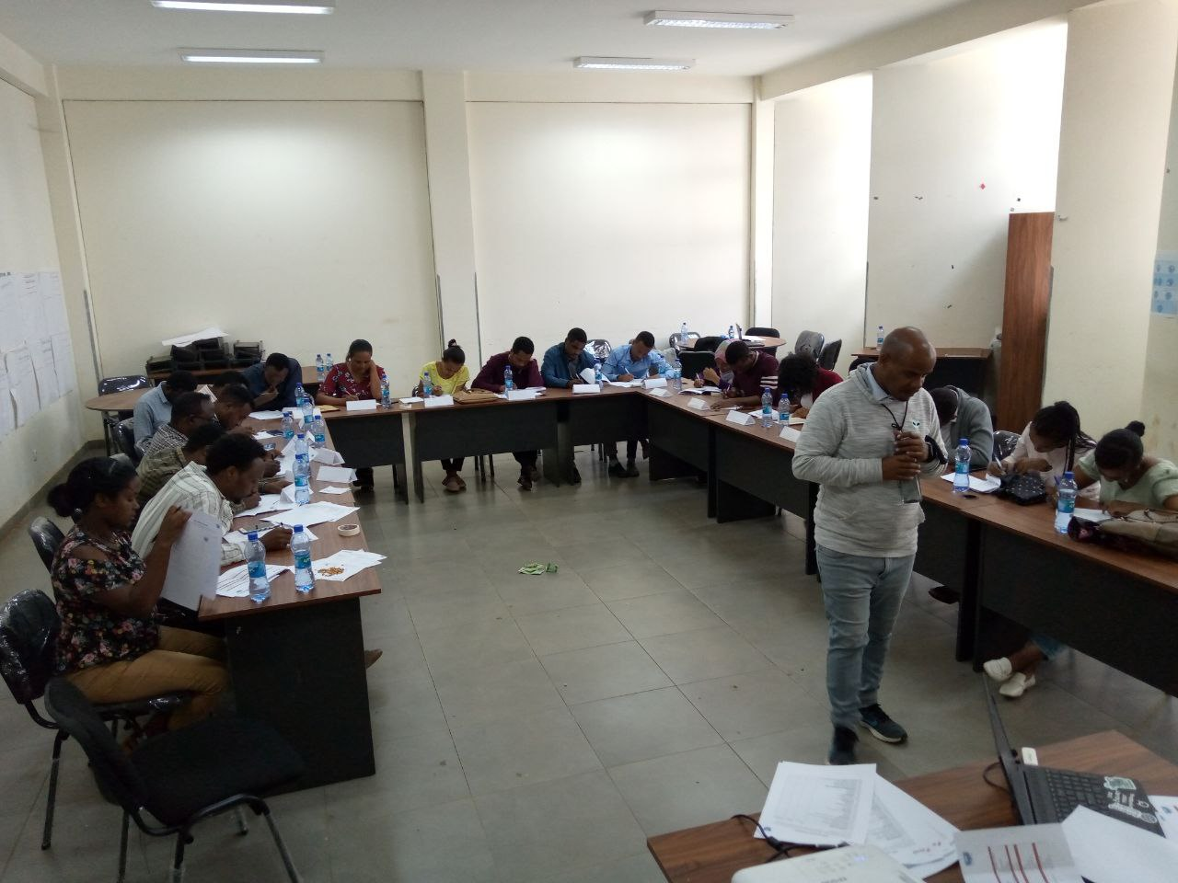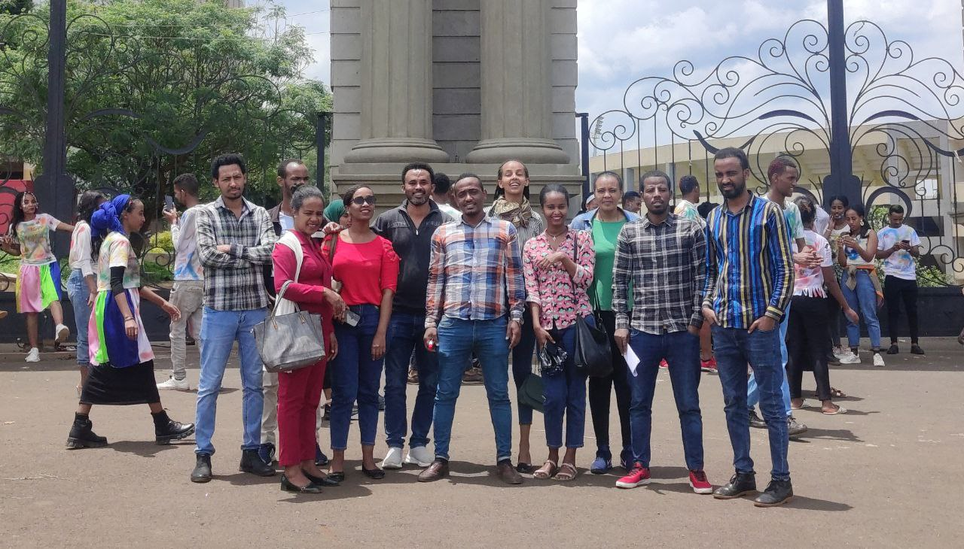

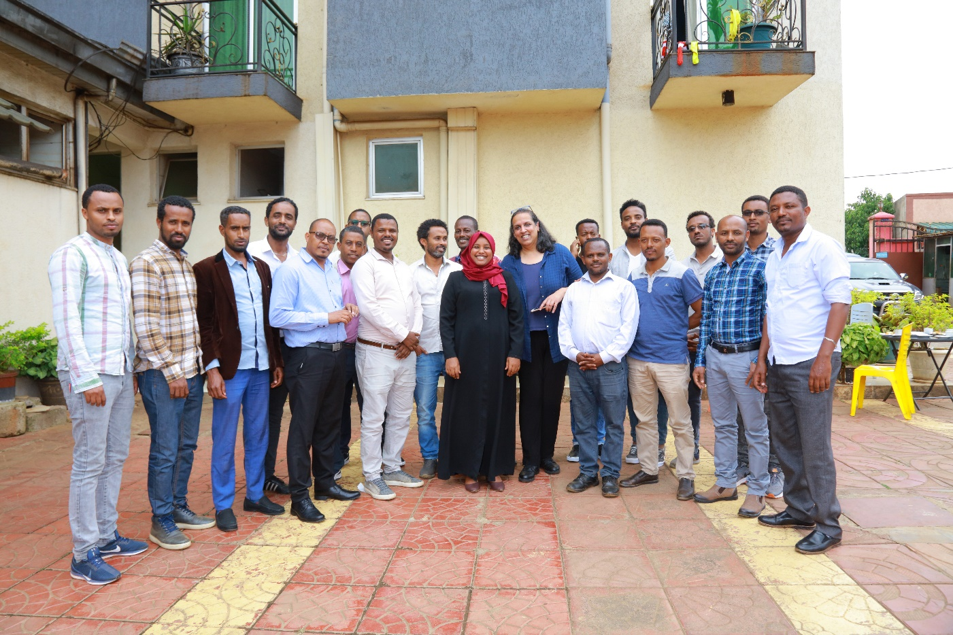
Picture of Trainers of Training at BONNI INTERNATIONAL Hotel

About the training
The training was organized by Jimma University Career Development and Entrepreneurship Center with collaboration with Brandeis University and Save the children Ethiopia Country office to Promoting “Opportunities, Education, Through Training, Education Investment and livelihoods (POTENTIAL)” with a specific focus on institutional capacity development support to Ethiopian higher education institutions, Jimma University starting from January 27-30/2020 at BONI INTERNATIONAL HOTEL.
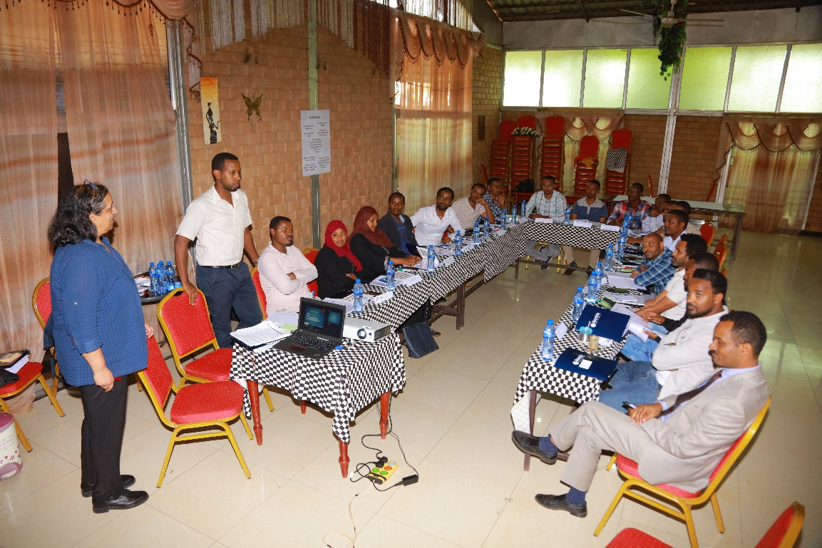

Participants
In this training more than 21 trainers are participated. Among these 18’s is from jimma university that comprised all colleges and institutes and the rest are from JigJiga University staffs.
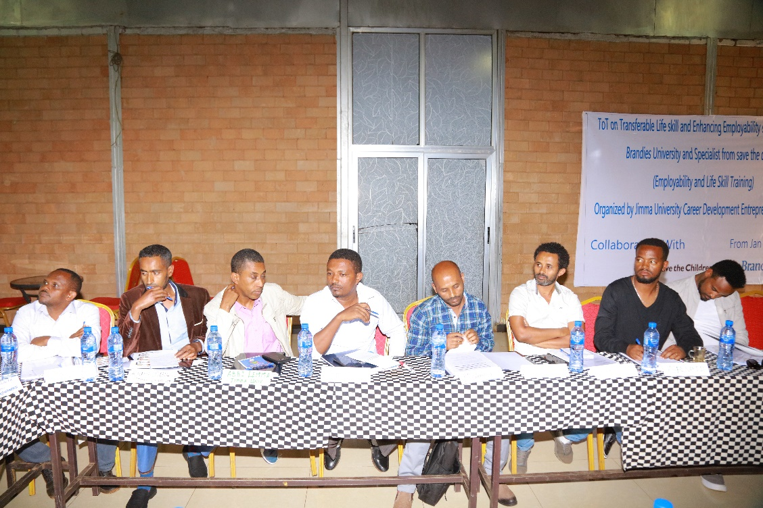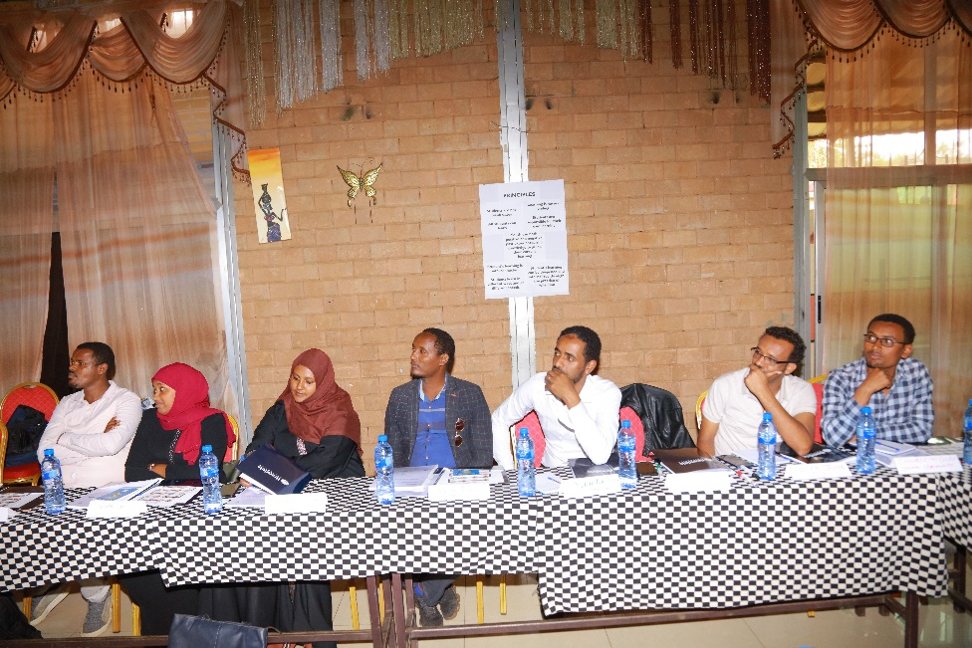

Objectives of the Transferable life skills 2020 Training of Trainers
- Frame the big picture-significant of TLS
- Share high level value framework behind the curriculum;
- Positive youth development
- Gender balanced approach
- Growth mindset
- Trainers need to be self –reflective, learners themselves
- Class room management and teachable moments.
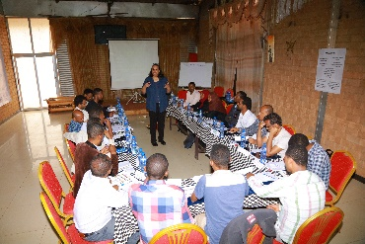
In addition to this, the training will be able the trainee;
- Deepen participant’s familiar with some transferable life skills to support their plans for strengthening students’ employability skills,
- Build participants’ facilitation skills through direct engagement with curriculum activities.
- Strengthen participants’ critical analysis through opportunities to provide and receive feedback.
- Provide coaching and support around curriculum implementation.

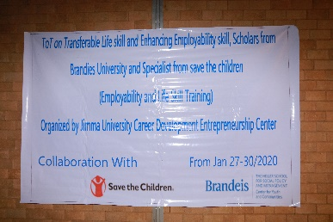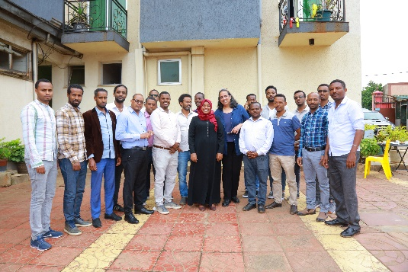

Feedback

by the specialist Trainers from Brandeis and save the children
- Jimma university was organized as they expected specifically dissemination of information and composition of the trainee at the college, promotion material was early prepared some stationary material was covered by the center,
- The motivation of the trainee was highly appreciated,
By the trainee
- The training was feet as expected stated by the objective
- The facilitation technique was high level training
- The certificate prepared by the save the children and brandies was mistake,

GC students Employability and Job Searching skill Training and Entrepreneurship Skills Training conducted 2020/2021/2022 more than 3500 students were participated from all campus and colleges of each graduated Bach’s;
show as a picture

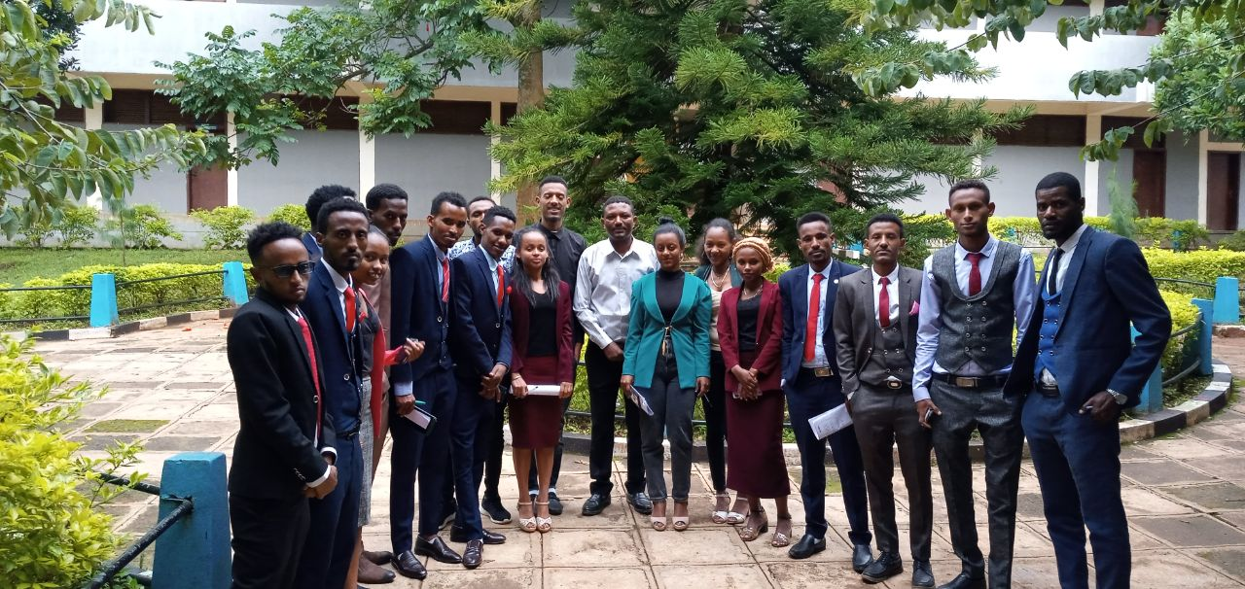
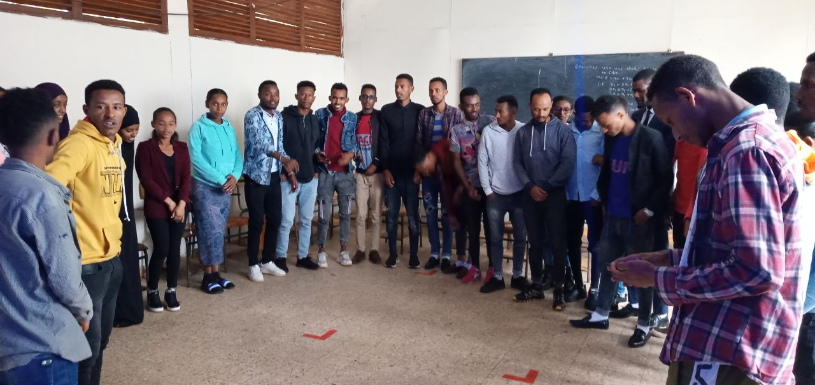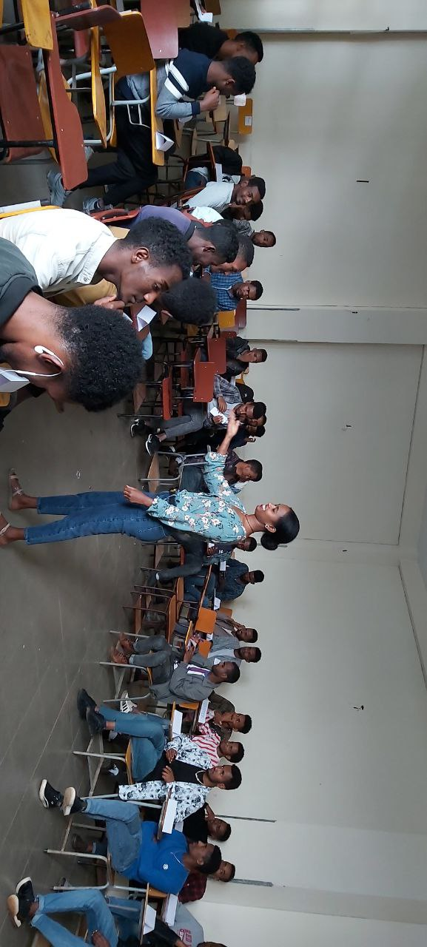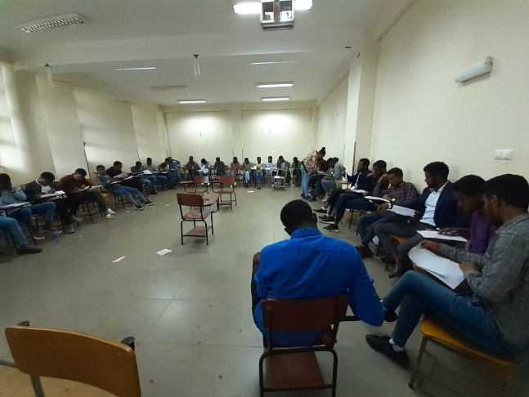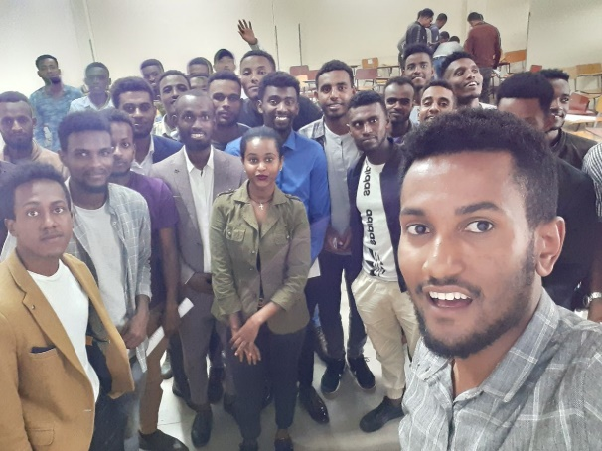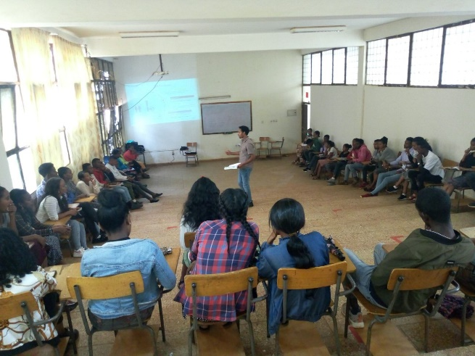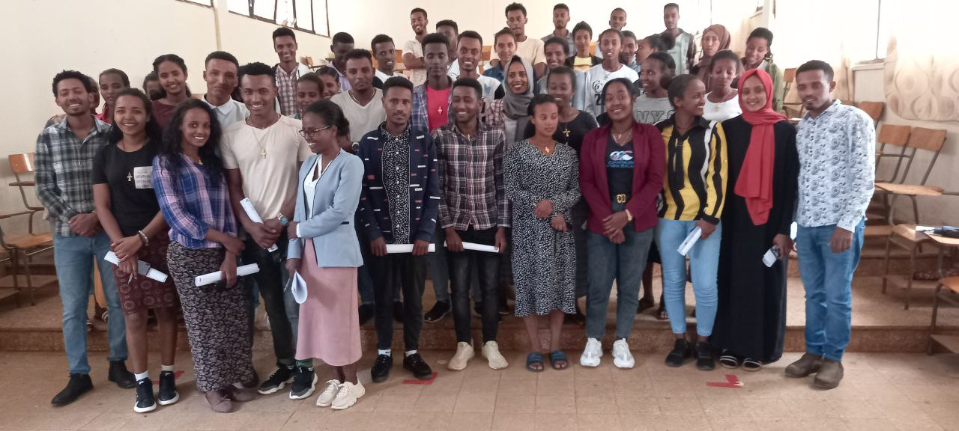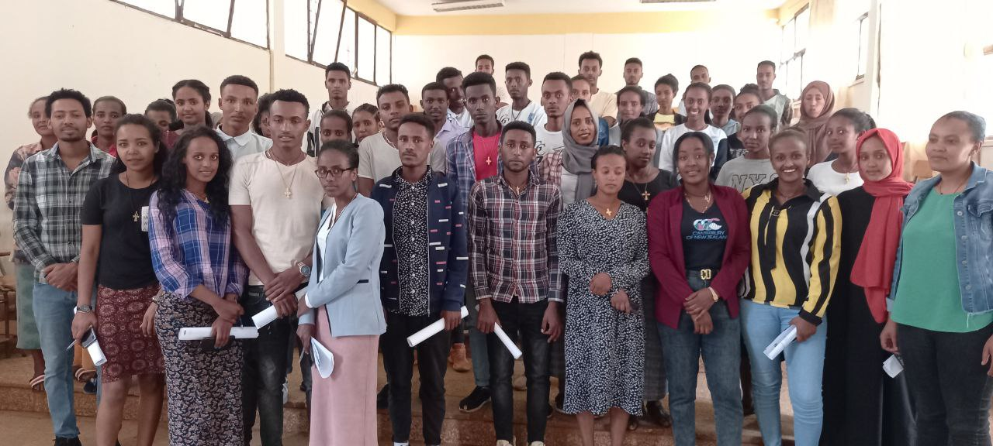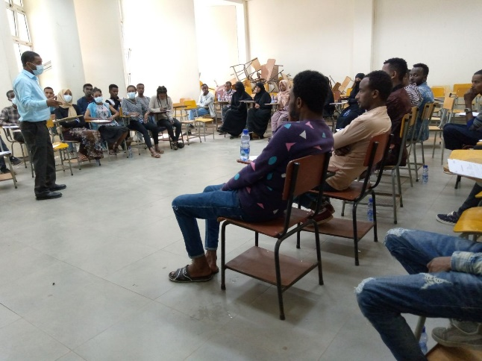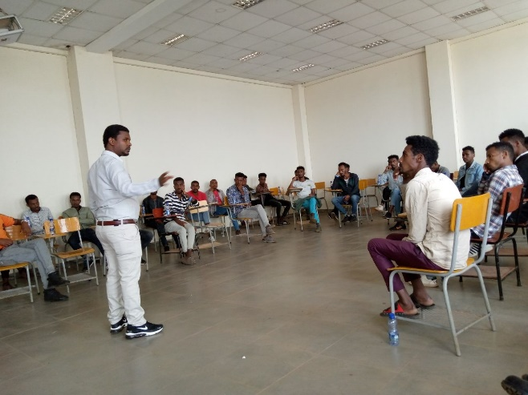

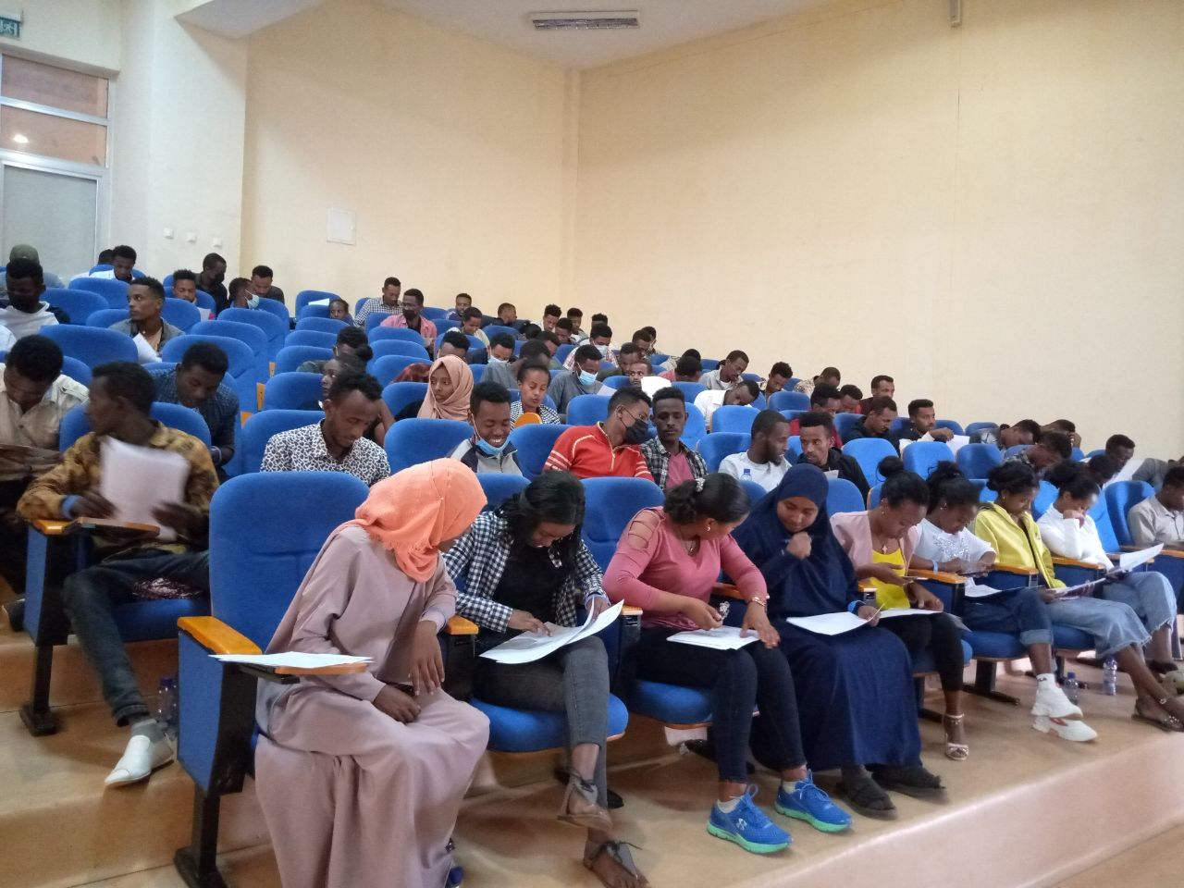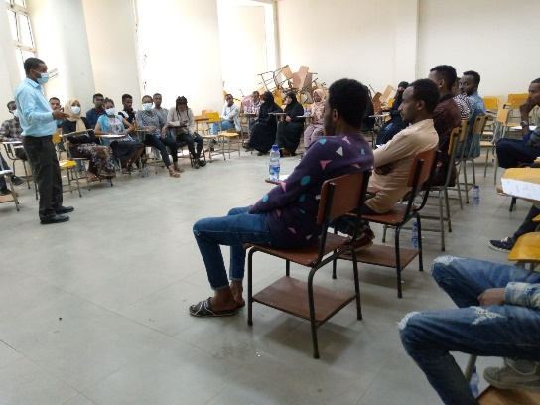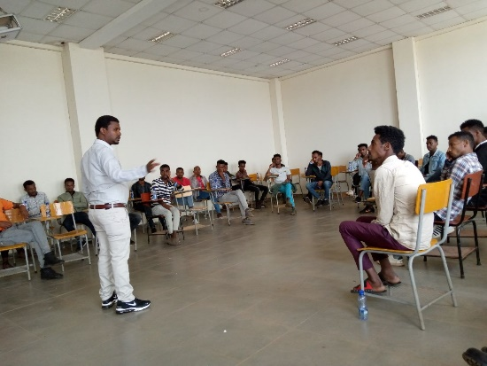
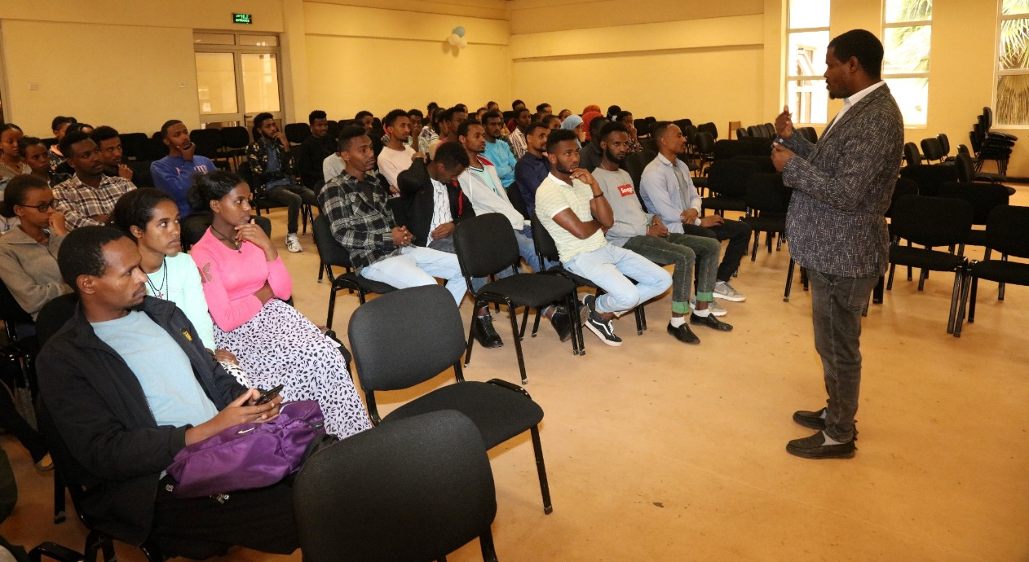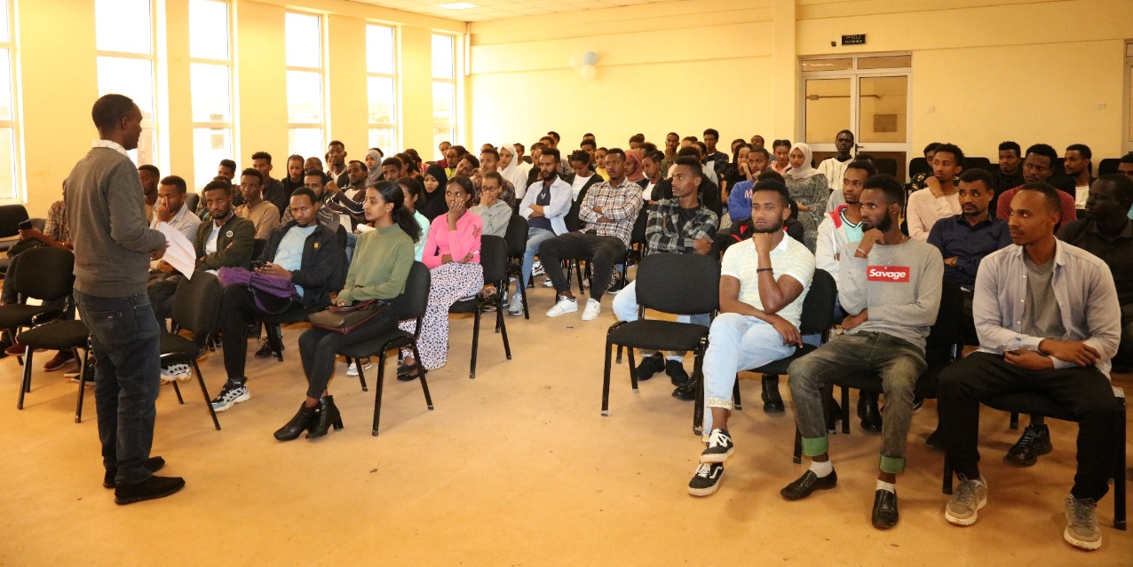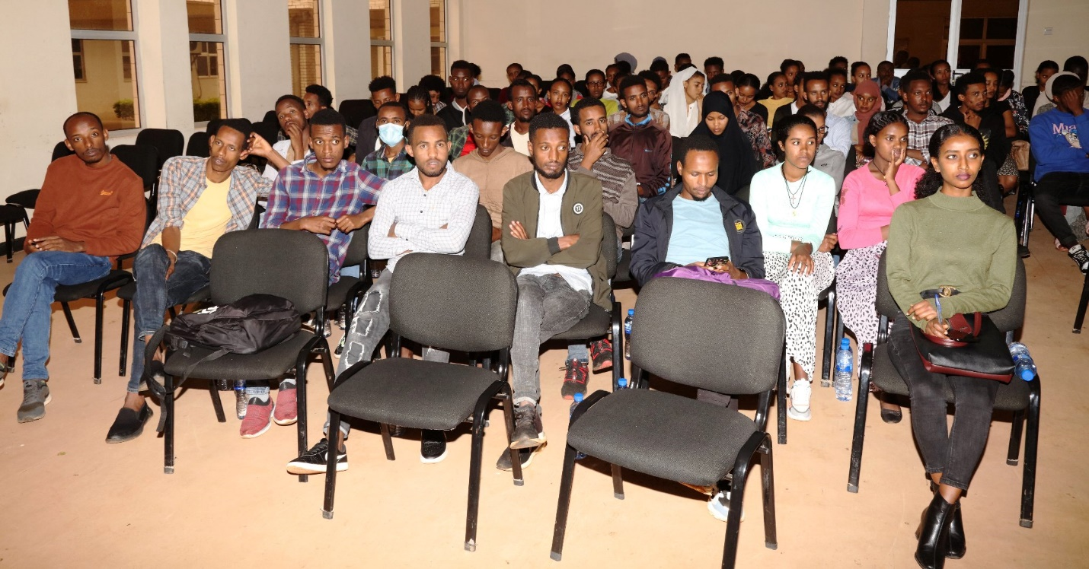

Career Fair; 2022
Annual Career Expo 2022 reaches Jimma University!! graduates of 2022 have been flocking to the job fair all day with CVs in their hands, and big hopeful smiles on their faces 😄😄 Take a look at some of the days’ activities and the colorful opening ceremony…!!
820 students and 21 company participated
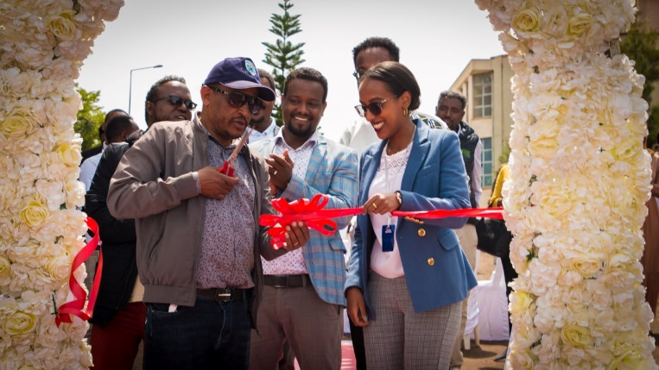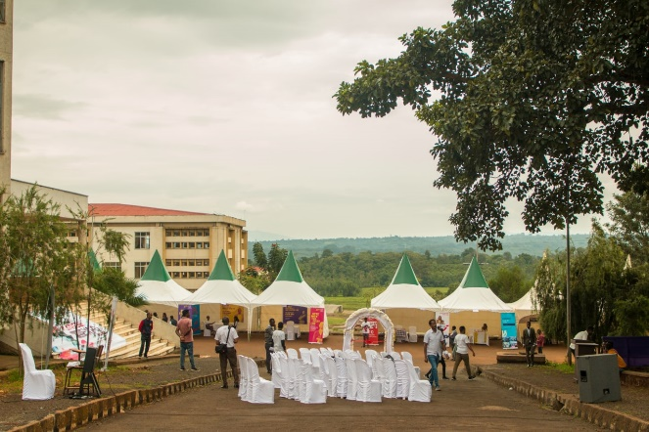
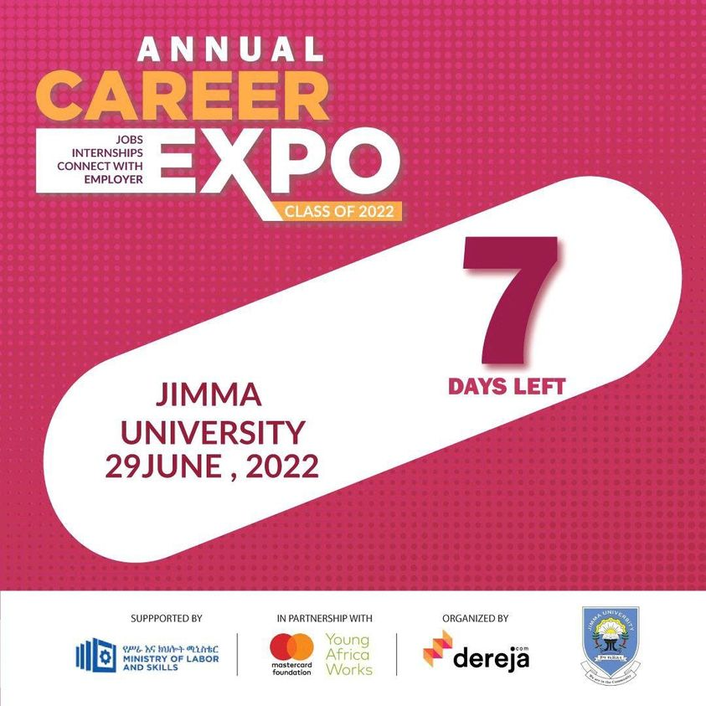
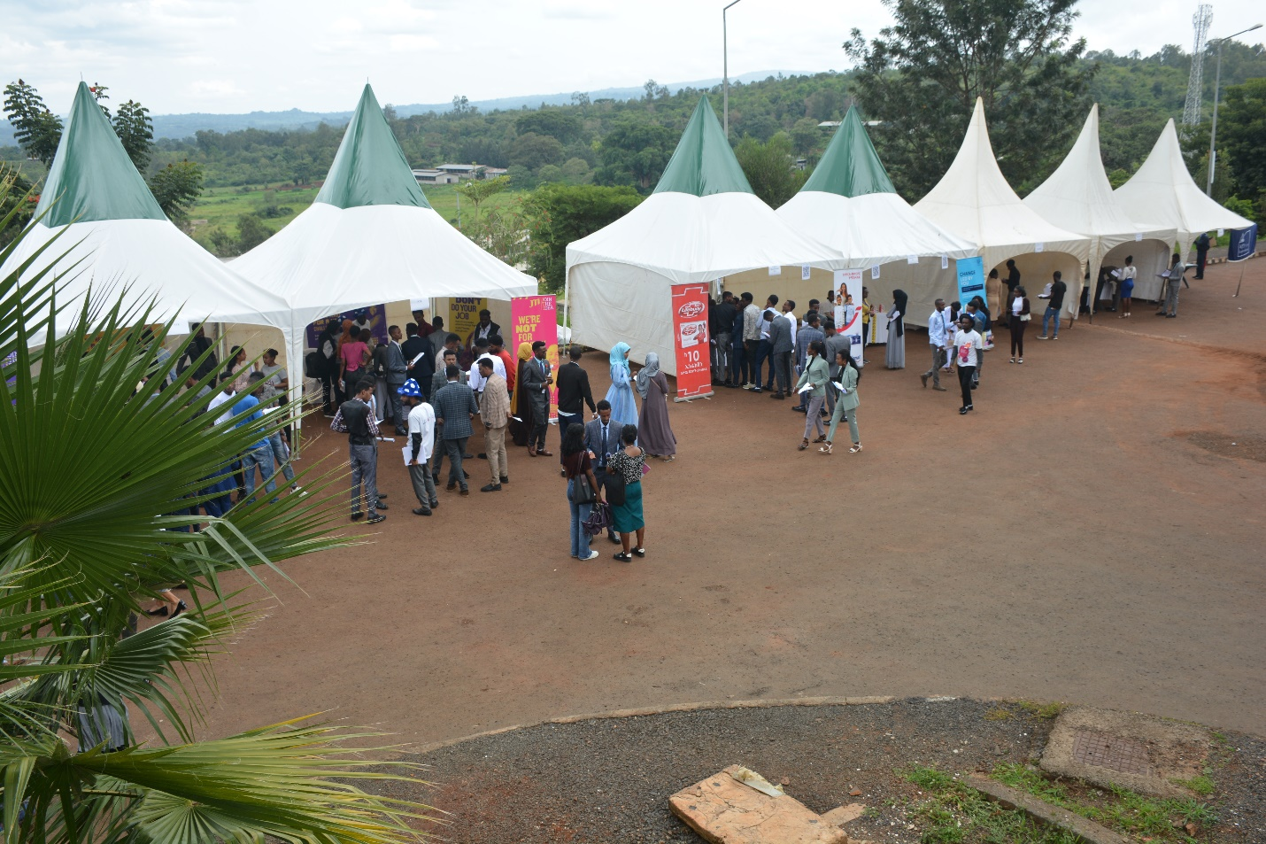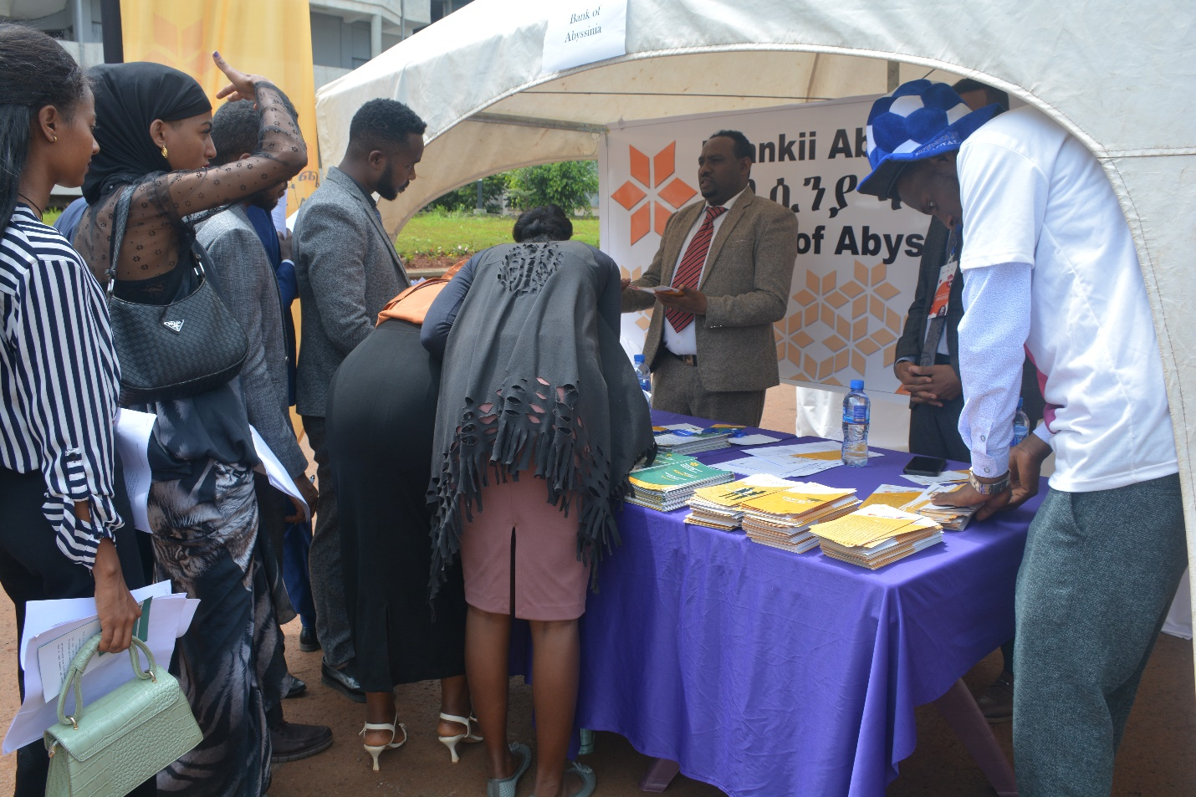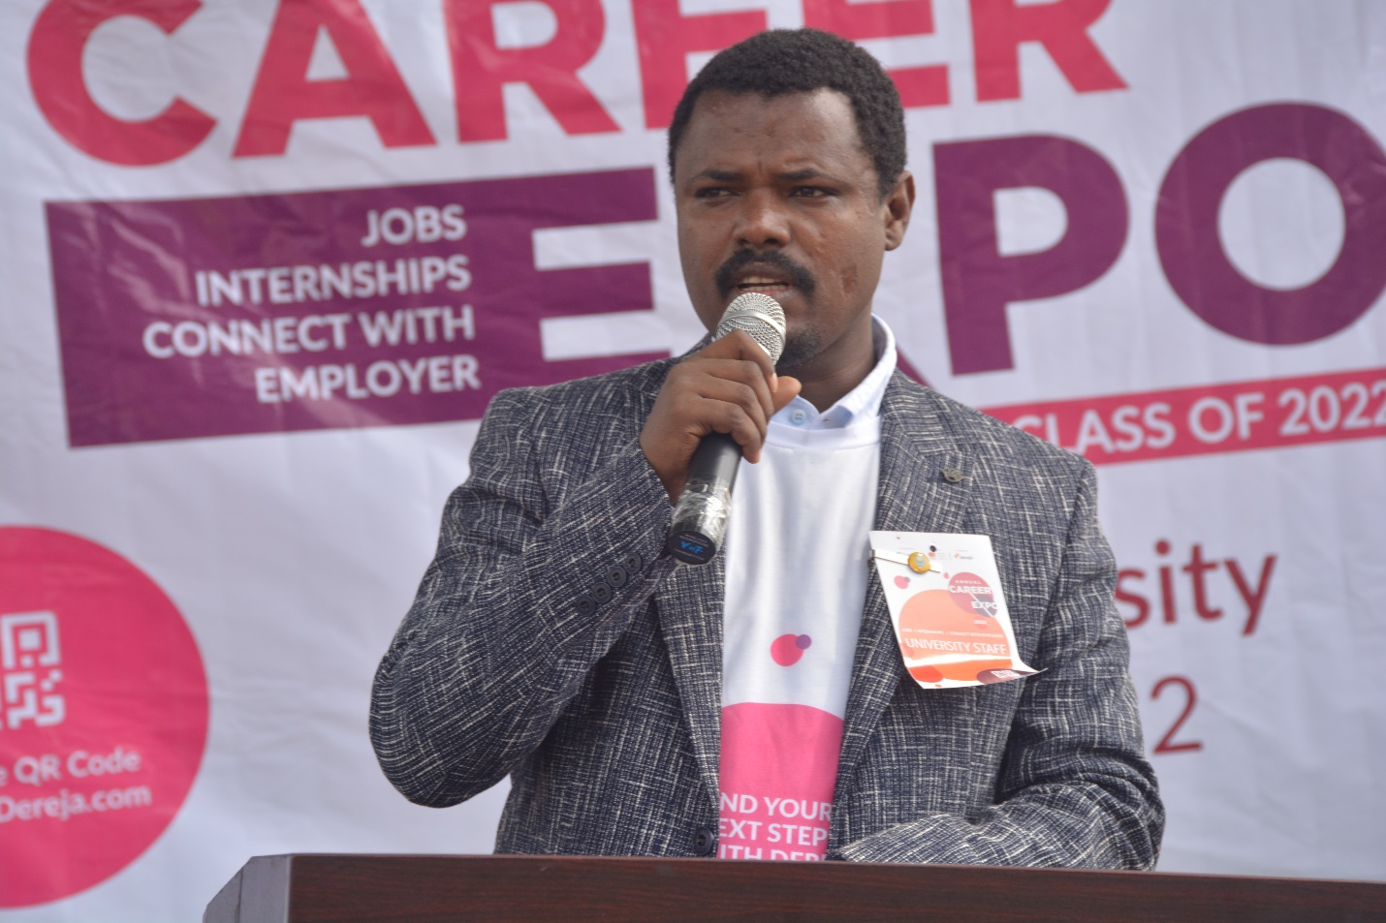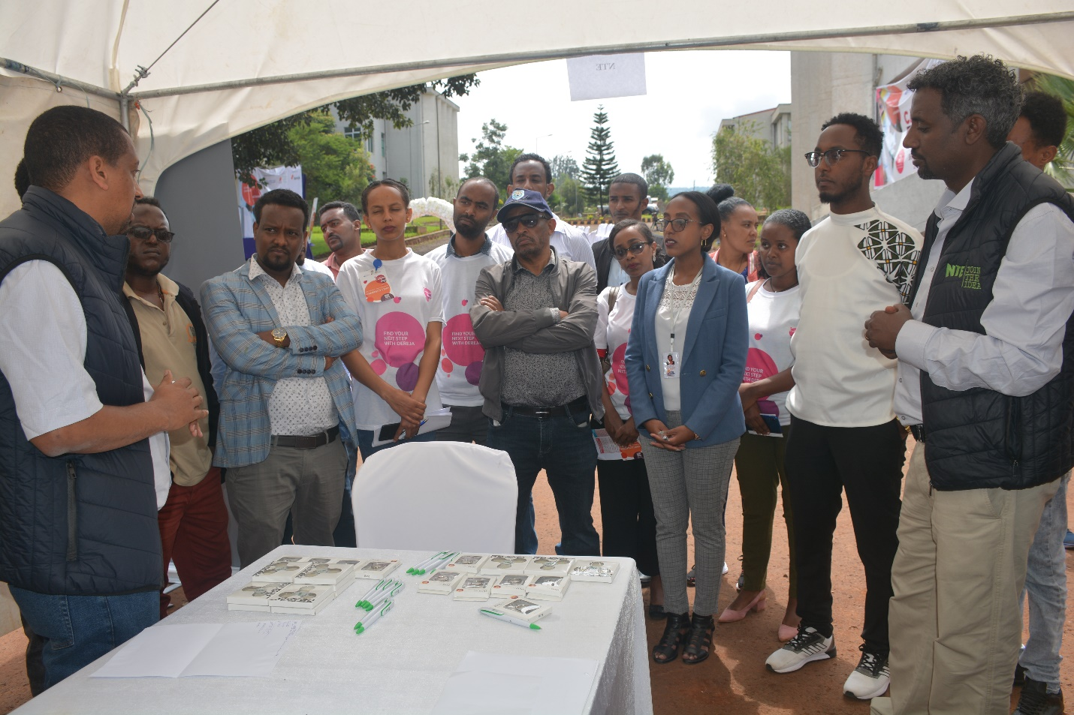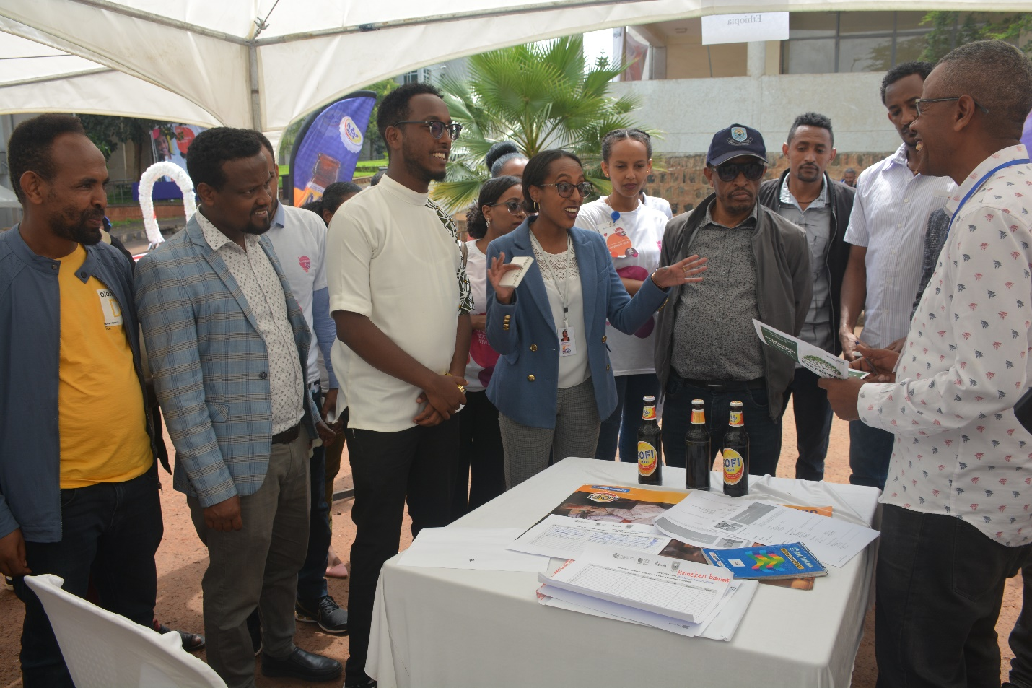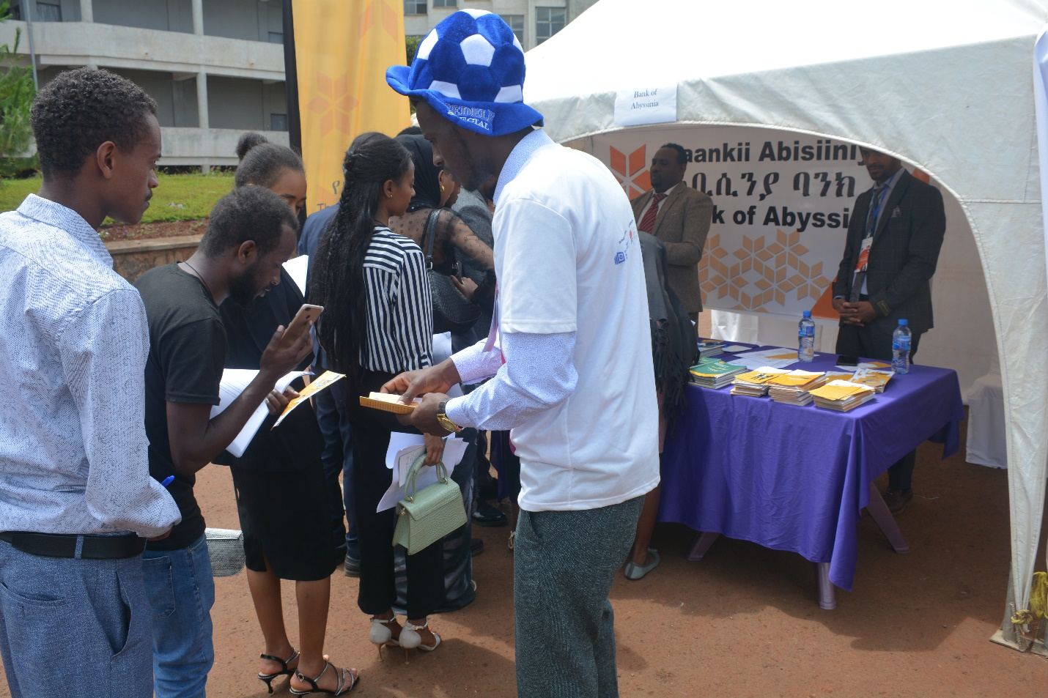
Thank you

